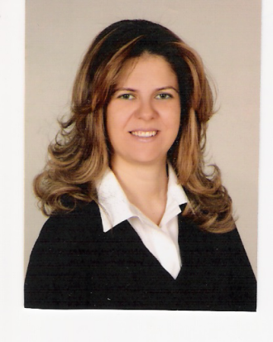
CURRICULUM VITAE

Name – Surname : MÜGE GÜNEŞ
Title : Instructor
Education : MA

Degree | Field of Study | University | Date
Bachelors | Sinology(Chinese Language and Litarature  Turkish Language and Literature | Ankara University  Anatolian University | 1986-1990  2014-2020
Masters
PhD

Administrative Duties & Additional Responsibilities
Place | Duty/Responsibility | Date
Ankara University of TÖMER Tunalı Hilmi Branch | Turkish Instructor for Foreign Students  (All levels) | 1992-1994
Ankara University of TÖMER  İstanbul Şişli Branch | Turkish Instructor for Foreign Students(In All levels for Turkic Republic and Europion Students)  Editing Manager for The Journal of Sişli Branch  Testing Member and Creating Test Bank for Şişli Branch in all levels | 1994-1998
MEDİ-KASEV  TÖMER Kadıköy | Turkish Instructor for Foreign Students(In All levels for Europion Students) | 1999-2001
Private Doğuş Primary and High School | Chinese Teacher(For Secondary and High School Students) | 2003-2007
Doğuş University | Chinese Instructor(Modern Chinese I) | 2005-2007
British Side Language School Beşiktaş | Turkish Instructor for Foreigners(Teaching Basic Level Turkish For Europion-English Language Teachers at British Side) | 2011-2012
Özyeğin University | Chinese(CHN 101)  Turkish Instructor For Foreign Students  (TURK 101A – TURK 101B,  TURK 102A, TURK 201A) | 2012  2012-2013
Bahçeşehir University | GEP0411 Instructor of Modern Chinese I – II | 2010-2020
Bahçeşehir University | Turkish Instructor For Foreign Students(TLL1005-Basic and TLL1006- Intermediate Level of Turkish For Turkic Republic and Europion Students) | 2013-

Diplomas & Certifications:

Place | Diploma/Certificate | Date
Ankara Ogün Computer Course  (10 months) | Certificate of Computer Programming | 1992
A.U. TÖMER English Language Course  (6 months) | Language Certicate | 1993
Mimar Sinan University(6 months) | Document of Teaching Certificate | 1995
Certificate of Computer Course at National Education of Turkish Republic in Kızılay,Ankara(8 months) | MS Office, Hardware, Software, Accounting | 2003-2004
Municipality of İstanbul İSMEK  Diction Course(5 months) | Certificate of Diction | 2014-2015
Anatolian University(Turkish Language and Literature) (4 years) | Diploma of Turkish Language and Literature | 2014-2020

Contact Information
Phn : 0535 356 03 71 | e-mail: mgunes70@gmail.com  muge.gunes@sfl.bau.edu.tr

